Case Study for Decision Table –
Search 5 tables for decision table. Create condition based on corresponding actions.
1. Customer Order Discount
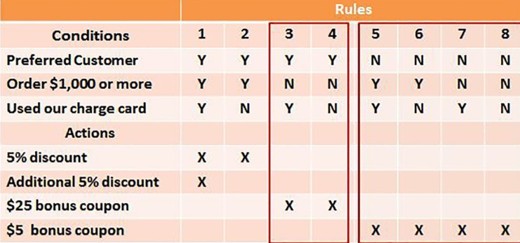
Conditions:
- Preferred Customer
- Order $1,000 or more
- Used our charge card
Actions:
- 5% discount
- Additional 5% discount
- $25 bonus coupon
- $5 bonus coupon

2. Electricity Billing
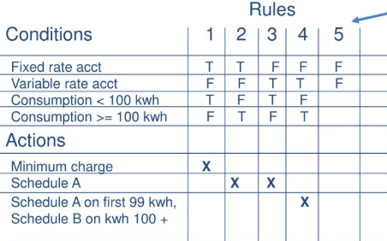
Conditions:
- Fixed rate account
- Variable rate account
- Consumption < 100 kWh
- Consumption ≥ 100 kWh
Actions:
- Minimum charge
- Schedule A
- Schedule A on first 99 kWh
- Schedule B on kWh 100+

3.Chemical Request Approval
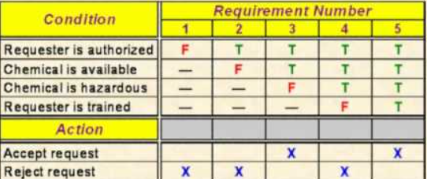
Conditions:
- Requester is authorized
- Chemical is available
- Chemical is hazardous
- Requester is trained

Actions:
- Accept request
- Reject request

4.Printer Troubleshooting
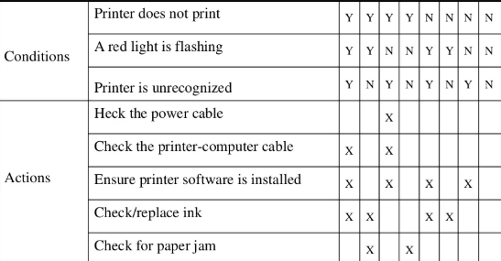

Conditions:
- Printer does not print
- A red light is flashing
- Printer is unrecognized

Actions:
- Check the power cable
- Check the printer-computer cable
- Ensure printer software is installed
- Check/replace ink
- Check for paper jam

5.Shipment Processing

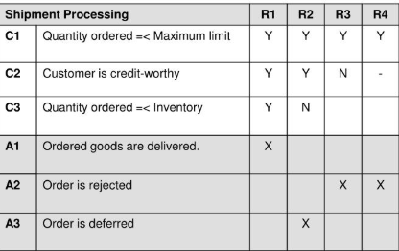
Conditions:
- Quantity ordered ≤ Maximum limit
- Customer is credit-worthy
- Quantity ordered ≤ Inventory

Actions:
- Ordered goods are delivered
- Order is rejected
- Order is deferred

